

Programme Name: ________**BCS HONS**_______________________________________

Course Code: __**CSC 2514**________

Course Name: _______**Web System and Technologies**_____________________________

**Open Book Examination**

Date of Submission: ______**9/26/2021**_____________

**Submitted By: Submitted To:**

Student Name**: Dipesh Tha Shrestha** Faculty Name**: Prakash Chandra**

IUKL ID: **041902900028** Department**: LMS**

Semester**: Fourth Semester**

Intake**: September 2019**

1. **Explain the role of the internet in the modern day education system and also mention different internet based tools and technologies used for teaching and learning.**

**Answer:**

The Internet is the most useful technology of our time, assisting us not only in our personal life but also in our professional life. It is widely used for educational purposes to gather information, conduct research, and expand one's knowledge of various subjects. Internet has become more important as well as a powerful tool in the world which is preferred by everyone.

The Internet is a great platform for students to learn throughout their lifetime. They can use the internet to learn new things and even acquire degrees through online education programs. Teachers can also use the internet to teach students around the world. Internet offer individual learners increased freedom from the physical limitations of the real world. This is often expressed in terms of reducing constraints of place, space, time, and geography, with individuals able to access high-quality learning opportunities and educational provision regardless of local circumstances. Internet has allowed students to be in constant touch with their teachers or with other fellow classmates with the help of social media, messaging apps and chat forums. Parents can interact as well as communicate with teachers and school authorities about their kid’s performance in the school. Interaction with the likeminded people on forums can help students to explore new ideas and enrich their knowledge.

Internet allow education to take place on an any time, any place, any pace basis. it provides speedy access to the latest information that might not always be found after spending laborious hours in musty libraries. Even past question papers on exams are available on the internet now, thus making it easy for students with internet access to prepare better for exams. Teachers can use it as a teaching tool by posting their teaching materials (notes and videos) on school website. The learning process becomes interesting and diverse with the use of tutorial videos and notes. Teachers can teach with the use of animation, PowerPoint slides, and images to capture the students’ attention.

ClassDojo, Quizlet, W3school, tutorial Point, Google Classroom, Microsoft Team are some internet based tools and technologies used for teaching and learning.

1. **Explain in detail, how a web page is retrieved from the web server with required diagram.**

**Answer:**

As we know, A web page is a hypertext document that a website provides and that is displayed to a user in a web browser. A website is typically made up of several web pages that are linked together in a logical manner.

 web server is a computer that runs websites. It's a computer program that distributes web pages as they are requisitioned. The basic objective of the web server is to store, process and deliver web pages to the users. This intercommunication is done using Hypertext Transfer Protocol (HTTP). The Web Server is requested to present the content website to the user’s browser. All websites on the Internet have a unique identifier in terms of an IP address. This Internet Protocol address is used to communicate between different servers across the Internet.

Web server software is accessed via a website's domain name and ensures that the site's content is delivered to the requesting user. There are several components on the software side, including at least an HTTP server. HTTP and URLs are understood by the HTTP server. A web server is a computer that houses web server software as well as other website-related files like HTML documents, images, and JavaScript files. When a web browser, such as Google Chrome or Firefox, requires a file hosted on a web server, the browser will make an HTTP request for the file. When the web server receives the request, the HTTP server accepts it, finds the content, and sends it back to the browser via HTTP. When a browser requests a page from a web server, the process is broken down into several steps. A person will first type a URL into the address bar of a web browser. The domain name's IP address is then obtained by either translating the URL through DNS (Domain Name System) or searching the web browser's cache. The browser will be directed to a web server as a result of this action. The browser will then use an HTTP request to request the specific file from the web server. The web server will respond by sending the requested page to the browser via HTTP once more. The web server will respond with an error message if the requested page does not exist or if something goes wrong. The webpage will then be displayed by the browser. This is how web page is retrieved from the web server.

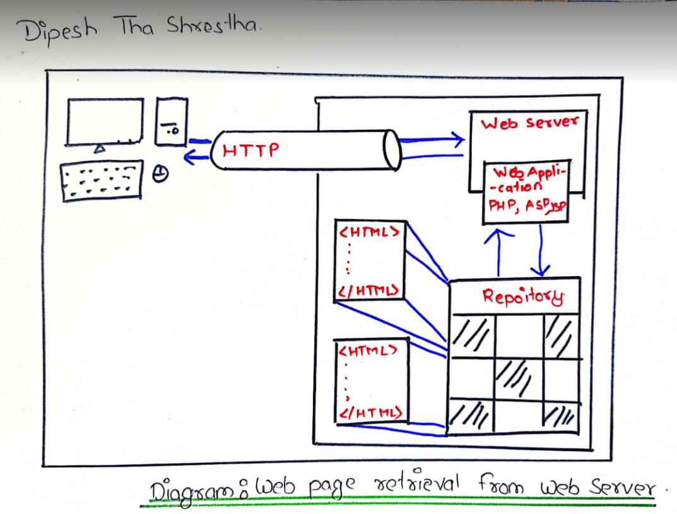

1. Write Html And Internal CSS code

Code:

<!DOCTYPE html>

<html>

<head>

<style>

fieldset{

    border: 3px solid ;

   width: 50%;

}

div.head{

text-align: center;

}

div.product {

  margin: 5px;

  float: left;

  width: 190px;

  border: 3px solid #ccc;

}

div.product img {

  height: auto;

  width: 100%;

}

div.pricers {

  padding: 15px;

  text-align: center;

}

</style>

</head>

<body>

<fieldset>

<div class="head"><b>PRODUCTS AVAILABLE</b></div>

<br><br>

<div class="product">

    <img src="rice.png" alt="rice" width="600" height="400">

  </a>

  <hr size="1" width="90%" color="black">

  <div class="pricers">price: Rs:<del>30</del> 20 per kg<br>

  <button>Buy Now</button>

</div>

</div>

<div class="product">

    <img src="wheat.png" alt="wheat" width="600" height="400">

  </a>

  <hr size="1" width="90%" color="black">

  <div class="pricers">price: Rs:<del>40</del> 30 per kg<br>

  <button>Buy Now</button></div>

</div>

<div class="product">

    <img src="sugar.png" alt="sugar" width="600" height="400">

  </a>

  <hr size="1" width="90%" color="black">

  <div class="pricers">price: Rs:<del>100</del>70 per kg<br>

  <button>Buy Now</button></div>

</div>

</fieldset>

</body>

</html>

Output:

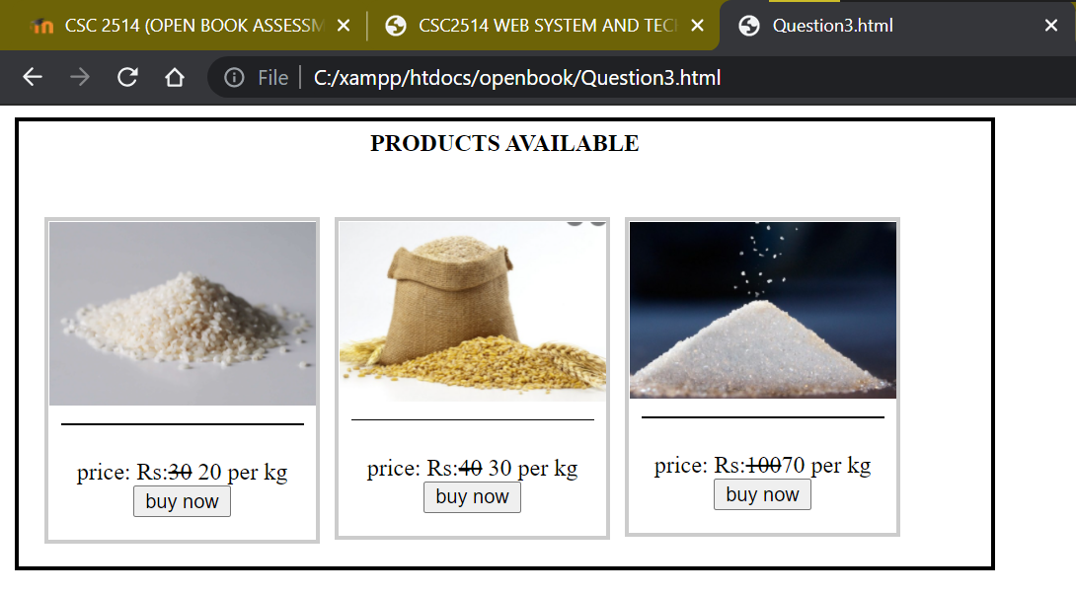

1. Write HTML code for the figure given below contained in register.php file.

Code:

<!DOCTYPE html>

<html lang="en">

   <head>

   <style>

fieldset{

*border*: 3px solid ;

*width*: 30%;

}

</style>

      <title>Registration</title>

      <meta charset="UTF-8">

      <meta name="viewport" content="width=device-width, initial-scale=1">

      <link href="" rel="stylesheet">

   </head>

   <body>

   <fieldset>

   <legend>Personal Information</legend>

   <form action="<?php htmlspecialchars($_SERVER['PHP_SELF']);?>" enctype="multipart/form-data" method="POST">

   Name: <br>

    <input type="text" name="name">

    <br>

   Email: <br><input type="email" name="email">

   <br>

   Select image to upload:<br> <input type="file" name="fileToUpload" id ="fileToUpload">

  <br>

   Website: <br>

  <input  type= "text" name = "website">

   <br>

   Comment: <br>

   <textarea name = "comments"></textarea>

  <br>

  Gender: <br>

   <input type="radio" name="gender" value="Female">Female

   <input type="radio" name="gender" value="Male">Male

   <input type="radio" name="gender" value="Others">Others

<br>

<input type="checkbox" value = "I accept all the condition" name = "checkbox"> I accept all the conditions

   <br>

   <input type="submit" name="Submit" value="Submit">

   </fieldset>

   </form>

   <!-- PHP CODES -->

 <?php

   $_target_dir = "photos/";

   $name=$age=$email=$gender=$file_path="";

   if($_SERVER['REQUEST_METHOD']=='POST' and isset($_POST['upload'])){

      $name=$_POST['name'];

     $email=$_POST['email'];

     $website = $_POST['website'];

      $comments = $_POST['comments'];

       $gender=$_POST['gender'];

      $checkbox = $_POST['checkbox'];

      // echo var_dump($_FILES['fileToUpload']);

      $target_file=$_target_dir.basename($_FILES['fileToUpload']['name']);

      echo $target_file;

      echo "<br>";

      move_uploaded_file($_FILES['fileToUpload']['tmp_name'],$target_file);

         $servername="localhost";

         $username="root";

         $password="";

         $db="sunway";

         $conn = new *mysqli*($servername,$username,$password,$db);

      if($conn->connect_error){

         die("Connection aborted");

      }else{

         $sql = "INSERT INTO person_detail(name, email, website, comments, gender, file_path, checkbox)VALUES('$name','$email','$website' '$comments', '$gender','$target_file', '$checkbox')";

         // echo $sql;

         echo "<br>";

         if($conn->query($sql)==TRUE){

            echo "<h1>Record Inserted</h1>";

            header("location:display.php");

         }else{

            echo "<h1>Error Occured</h1>";

         }

      }

   }

   ?>

   </body>

</html>

Output:

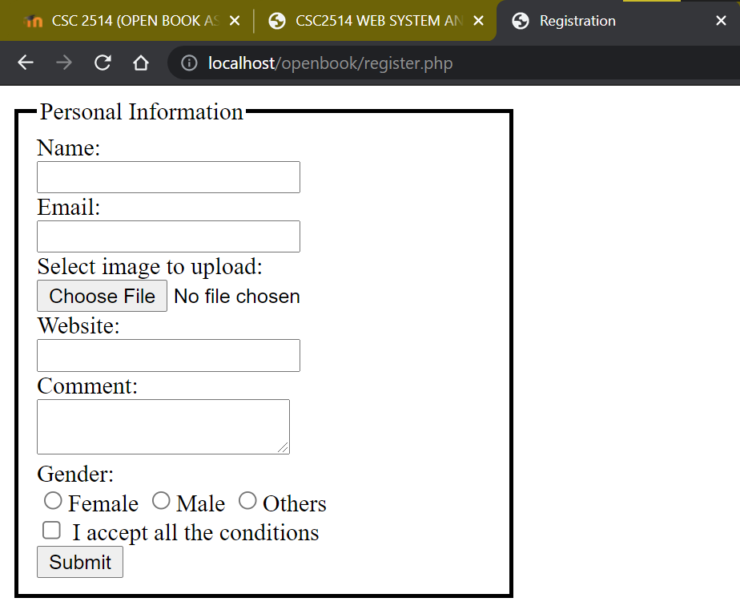

<!DOCTYPE html>

<html lang="en">

   <head>

      <title>Display details</title>

      <meta charset="UTF-8">

      <meta name="viewport" content="width=device-width, initial-scale=1">

      <link href="" rel="stylesheet">

        <style>

         .img{

*width*: 150px;

*height*: 150px;}

             #details{

*border*: 2px solid black;

*padding*:5px;

     }

   </style>

   </head>

   <body>

   <?php

   $servername="localhost";

   $username="root";

   $password="";

   $db="openbook";

   $conn = new *mysqli*($servername,$username,$password,$db);

   if($conn->connect_error){

      die("Connection aborted");

   }

   else

         {

      $sql = "SELECT * FROM person_detial";

      // echo "$sql";

      $result = $conn->query($sql);

      if($result->num_rows>0){

         while($row=$result->fetch_assoc()){

             echo '<div id = "details">'

             echo "<img src='".$row['file_path']."' height=150px width=150px>";

            echo "<br>";

            echo "Name: ".$row['name'];

            echo "<br>";

            echo "Email: ".$row['email'];

            echo "<br>";

            echo "Website: ".$row['website'];

            echo "<br>";

            echo "Comment: ".$row['comments'];

            echo "<br>";

            echo "Gender: ".$row['gender'];

            echo "<br>";

            echo $row['checkbox'];

            echo "<br>";

            echo "</div>"

         }

      }

   }

   ?>

   </body>

</html>

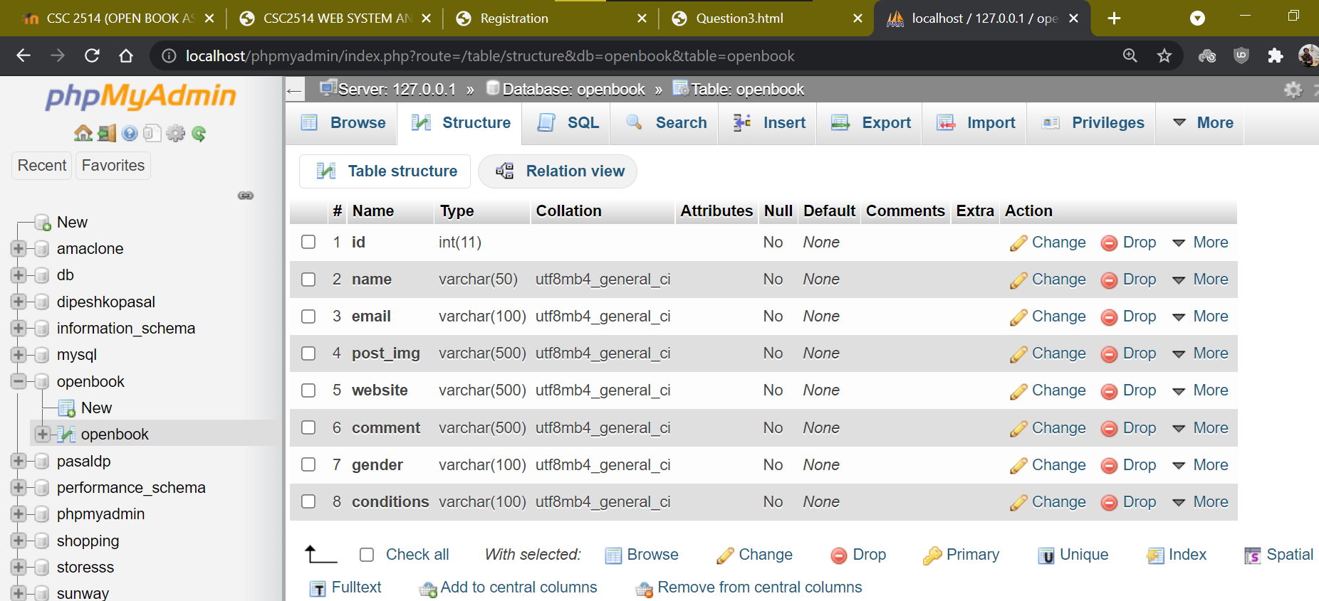

Code:

<!DOCTYPE html>

<html lang="en">

<head>

    <meta charset="UTF-8">

    <meta http-equiv="X-UA-Compatible" content="IE=edge">

    <meta name="viewport" content="width=device-width, initial-scale=1.0">

    <title>Question Number 5</title>

</head>

<style>

    button{

*margin*: 10px;

    }

</style>

<body>

    Number 1

    <br>

    <input type="text" id="num1">

    <br>

    <br>

    Number 2:

    <br>

    <input type="text" id="num2">

    <br>

    <br>

    <button onclick="ADD()">ADD</button>

    <button onclick="SUB()">Subtract</button>

    <button onclick="MUL()">Mutiply</button>

    <script>

// Addition function

*function* ADD() {

*let* field1 = document.getElementById("num1").value;

*let* field2 = document.getElementById("num2").value;

*let* sum = parseFloat(field1) + parseFloat(field2);

            if (!isNaN(sum)) {

                alert(sum);

            }

        }

        // subtractioin function

*function* SUB() {

*let* field1 = document.getElementById("num1").value;

*let* field2 = document.getElementById("num2").value;

*let* sub = parseFloat(field1) - parseFloat(field2);

            if (!isNaN(sub)) {

                alert(sub);

            }

        }

        // multiply finction

*function* MUL() {

*let* field1 = document.getElementById("num1").value;

*let* field2 = document.getElementById("num2").value;

*let* mul = parseFloat(field1) * parseFloat(field2);

            if (!isNaN(mul)) {

                alert(mul);

            }

        }

        ADD;

        SUB;

        MUL;

    </script>

</body>

</html>

Output:

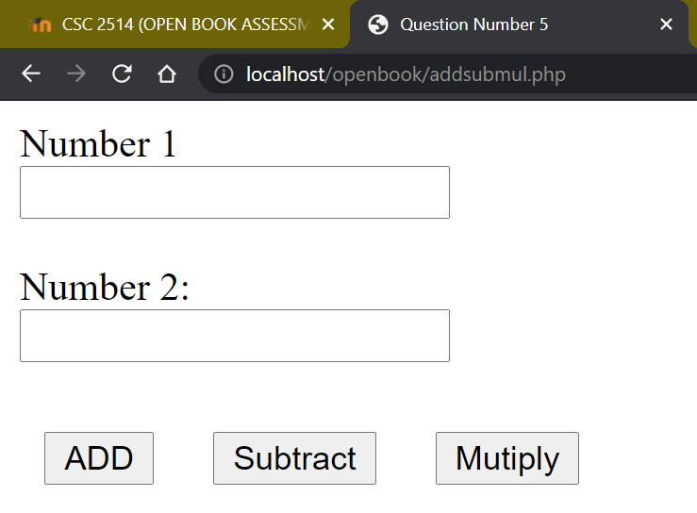

ADD

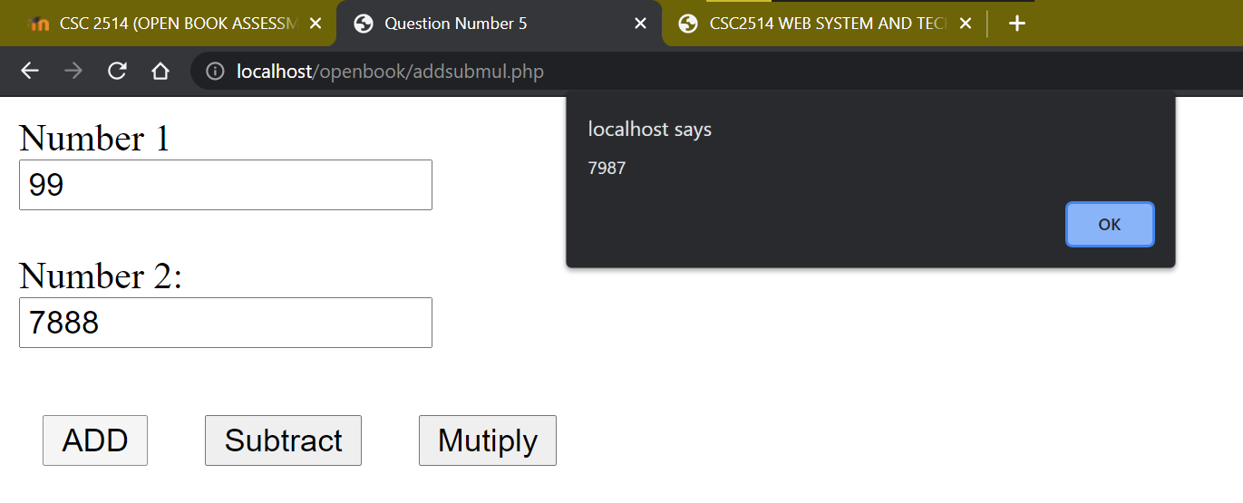

Subtract:

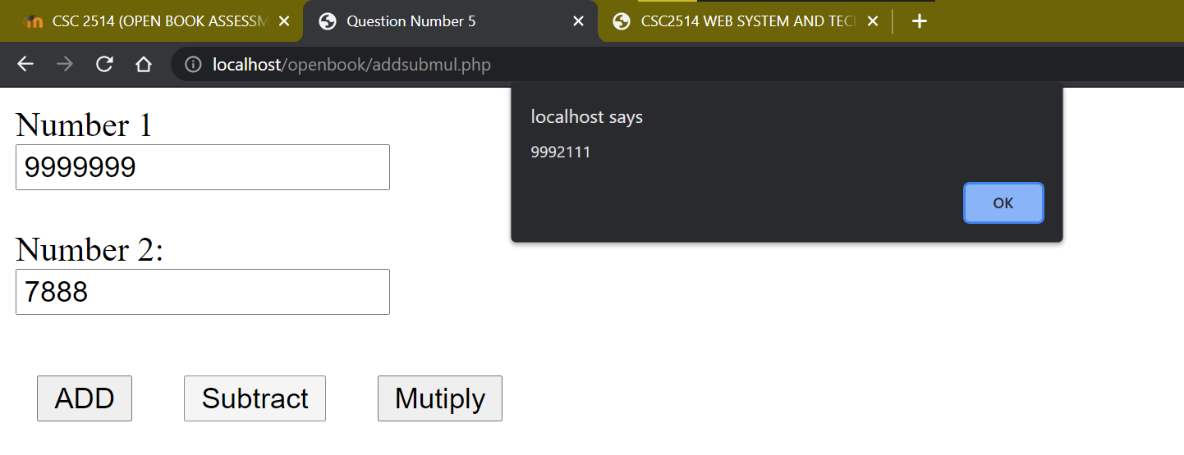

Multiply:

